Name - Vaibhav Navneet Jorvekar

* Create IAM user using terraform

1. Write code with vs code app in main.tf file

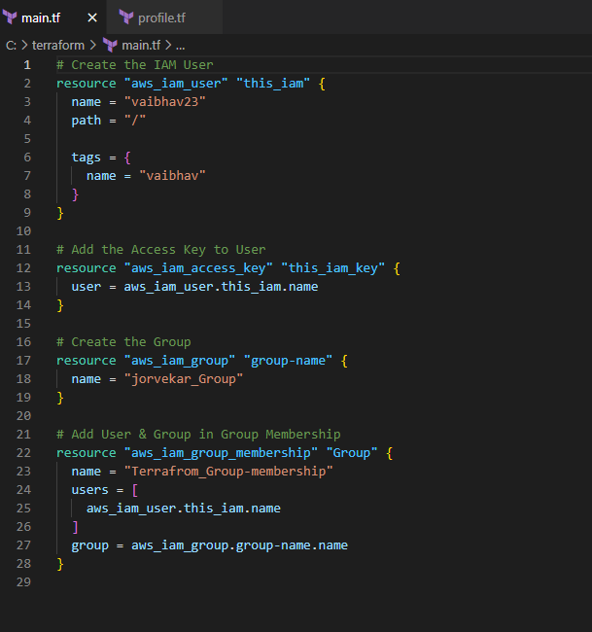

1. Write the access key and secret key in second file in profile.tf

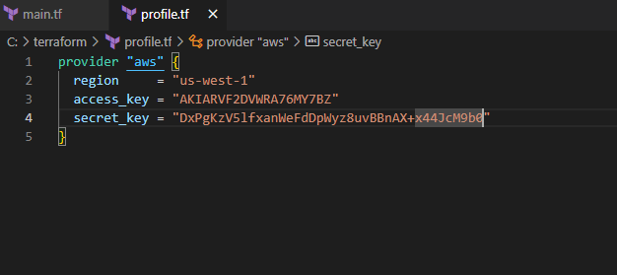

1. Open terminal and initialize the file to command #terraform init

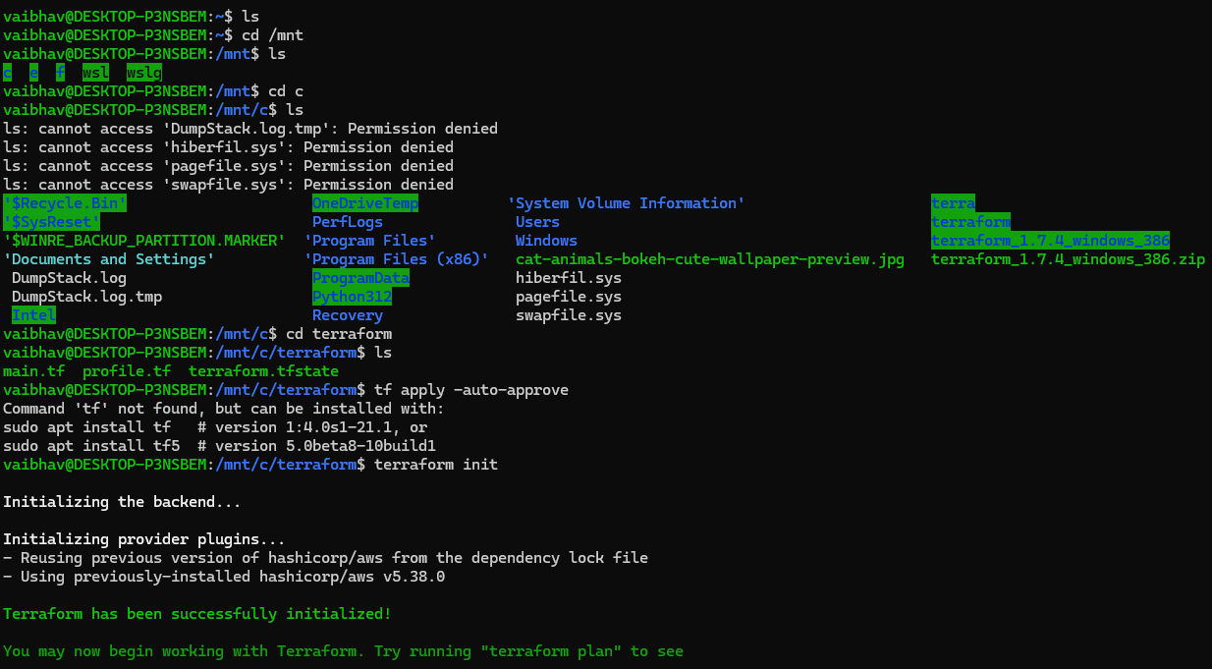

1. Apply the file in command #terraform apply

